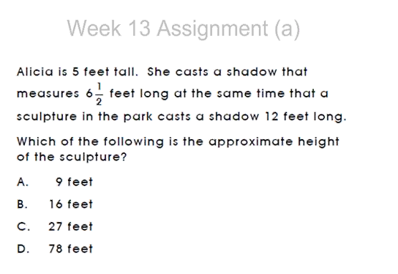

5/6.5 = 0.77

12\*0.77=9.2

The correct answer is A.